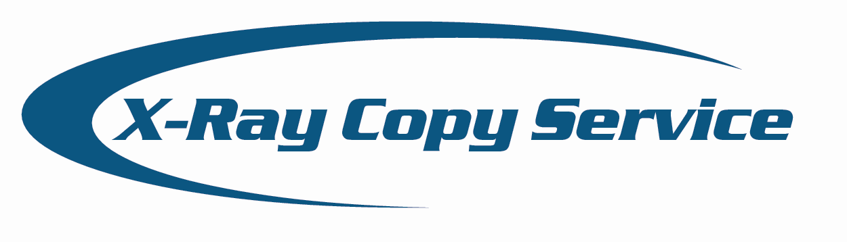
X-Ray Copy Service
Service Order Request Form

Instructions:
- Complete and print this form.
- Enclose this form with films or media into an approved shipping jacket or package.
- Ship via a reliable shipping service, with tracking abilities. We recommend FedEx.

Contact person:

Telephone number:

Description of the copy/digital job request:

Shipping address:
Ship To: | X-RAY COPY SERVICE  2536 Hi Ridge Drive  North Huntingdon, PA 15642

Questions? Click here to e-mail a representative or call 412-392-1952.

Mail all X-Rays to the following address

X-Ray Copy Service
2536 Hi Ridge Drive
North Huntingdon, PA 15642

